Water Supply System
Introduction
This chapter is about the basic and general study regarding water services available in the case study chosen which is “Star Avenue” in Sungai Buloh. The information mentioned is accociated with the case study upon how the water supply is available and being distributed throughout the whole building.
The Water services study covered water supply system, water distribution system and also water supply piping. The water supply will be analyzed to give a more cleared understanding about the water services.

Literature Review
Importance of water
- Apart from drinking it to survive, people have many other uses for water. These include:
- cooking
- washing their bodies
- washing clothes
- washing cooking and eating
- keeping houses and communities clean
- recreation; such as swimming pools
- keeping plants alive in gardens and parks
- Water is also essential for the healthy growth of farm crops and farm stock and is used in the manufacture of many products.
Without sufficient water supply. Our society will not have evolved and lived like today. With technologies evolving and improving. And on the other side, the amount of pollution around us is increasing. We depend on treated water to avoid threats. Enormous infrastructures were required to estimate the volume of water consumed by the community everyday.
In our country, There are number of private companies that supplies to millions of consumers everyday. SYABAS is one of the largest private companies that currently supplies treated water to over 7 million consumers in Selangor, Kuala Lumpur and Putra Jaya. SYABAS core business would be to relate the water supplied to consumers, which is then been processed and treated before supply for the consumers. Rainfall falls and river flows will be pumped to the water treatment plant, and is then treated by going through process of aeration, coagulation, flocculation, sedimentation, filtration, disinfection and conditioning. After those process, the water is then safe to consume but will be pump to the balancing reservoirs before being distributed.
SOURCES OF WATER
There are many ways in which we can collect water.
In Malaysia:
- Surface water: This is water which falls to the ground as rain or hail. This water is collected from a special area called a catchment. The catchment feeds water into a holding area via rivers, streams and creeks. The water is then stored in a natural or artificial (manmade) barrier called a dam or reservoir. Dams are usually placed at the lower end of a valley. Catchment areas are usually far away from towns or cities to lessen the chance of the water being polluted. There are laws which control human activities, such as farming and recreation in catchment areas and on dams to make sure that water supplies are kept potable.
- Rivers or lakes: Town or community water supplies are sometimes drawn directly from nearby rivers or lakes
- Rainwater tanks: The rainwater which falls on the roofs of houses is often collected using roof guttering leading through a pipe to a storage tank

In other countries:
- Excavated dams: Excavated dams are made by scooping out soil to make a large shallow hole. These dams are sometimes placed at the bottom of a slope to aid water collection. However, this can only be done in areas where the soil will not allow the water to drain away very easily through the ground. For example, in clay soils. Soils which do not allow water to drain away are called impervious. If a community wants a dam in an area where the soil is not impervious this can still be done by digging the hole and lining it with clay or an impervious liner, such as concrete or heavy plastic. Excavated dams are often used by farmers to supply water to stock.

Rock catchment areas and rockholes: Sometimes large rocky outcrops contain low areas in which water is trapped. These low areas make good natural dams. Often a wall can be built to increase the amount of trapped water.

Springs: These are found where underground water flows out of the ground naturally without the use of bores, wells or pumps. Springs often occur towards the bottom of a hill or on sloping ground.

Water Supply Law
Water supply and services in Malaysia is under the concurrent jurisdiction of the federal Government and State Governments, In order to increase the country’s water services quality particularly protecting consumer’s right, 2 legislative frameworks, namely National Water Services Industry (NSW) Act (2006) (Act 655) and the National Water Services Commission (SPAN) ACT (2006) (ACT65) were introduced.
With a well regulated water services in place, this will help to promote efficiency and long term sustainability of the water industry to benefit the consumers, investors as well as the operators. Consumers in Malaysia enjoy 24 hour water supply and water reliable and safe in terms of quantity and quality. It is treated according to international standards of drinking water set out by the World Health Organization (WHO). All domestic, commercial and industrial users are metered. Water tariff are vary from state to state.
CASE STUDY
In Star Avenue, the water is used as domestic purpose, for flushing toilets, is used in the air conditioning system and sprinkler system for emergency purpose when there’s a fire incident.
WATER STORAGE
Why Store Water?
Nearly all water systems include some form of storage, most commonly a tank. Storage can be used to:
- cover peaks in demand
- smooth out variations in supply
- provide water security in case of supply interruptions or disaster
- save your home from fire
- meet legal requirements
- improve water quality
- provide thermal storage and freeze protection
- enable a smaller pipe to serve for a distant source

Water Storage describes how to store water for home, farm, and small communities. It will help you design storage for just about any use, including fire safety and emergency, in just about any context—urban, rural, or village.
Due to differences in culture, climate and economic wealth, water demand varies between countries (smith and Ali, 2006). The demand for water also varies over the 34 hour period.
Therefore, storage capacity required for the building can be determined from hours to supply, pressure in mains and fire storage requirements.
In Star Avenue, Storage compartments are divided into Underground storage and Rooftop storage. Underground Storage: Necessary to collect water from the city mains during hours of supply if the pressure is unable to reach the rooftop storage. Rooftop Storage: Mandatory for flushing toilets and tap water for food and beverages.
To store water, water storage are to be installed and there are few requirements linking to installation:
- Tanks are installed on the bases above ground level, platforms where the tank is being located at is designed to bear the weight of the tank when it is filled to maximum capacity, without unnecessary alteration taking place.
- Metal tank are to be installed with a membrane of non-corrosive insulating material
- Tanks must be supported in a certain manner, so that no load is transmitted to any of the attached pipes.
- Tanks are located somewhere accessible for inspection, repairs, maintenance and replacement.
- Tanks must be provided with a cover, designed to prevent the entry of dust, roof water, surface water, ground water, birds and animals or even insects.
- Insulation from heat and cold should be also be specified.
- Tanks storing portable water should be located directly beneath any sanitary plumbing or any other pipes conveying non-portable water. 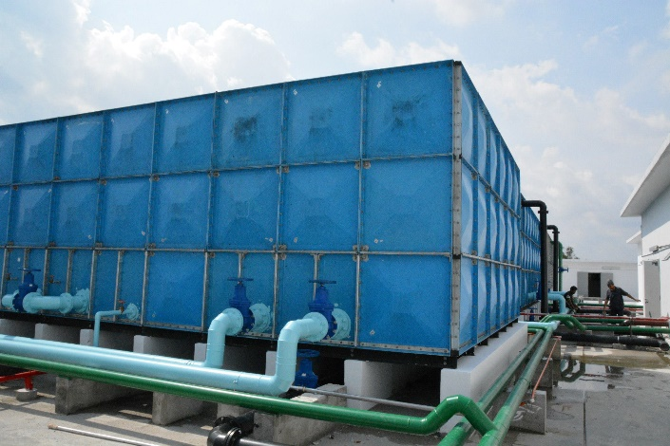
Figure 1: Water Storage tank located at roof level.

There are three main water tanks available at the basement area of Star Avenue, there are :
- R.C. Suction tank
- R.C. Sprinkler tank
- R.C. Wet Riser tank
The suction tank stored water that will used to pump water up to the domestic water tank, located at the roof (figure 1). If needed, the R.C. suction tank is used to store water from SYABAS distributed to the domestic tank. In case of situations when the water supply is temporarily stop, the R.C. suction tank will will act to back up water needed for the building.
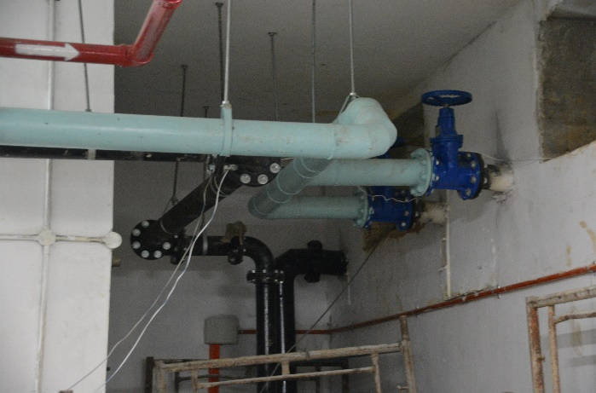
Figure 2: water pipe from the R.C. Suction tank
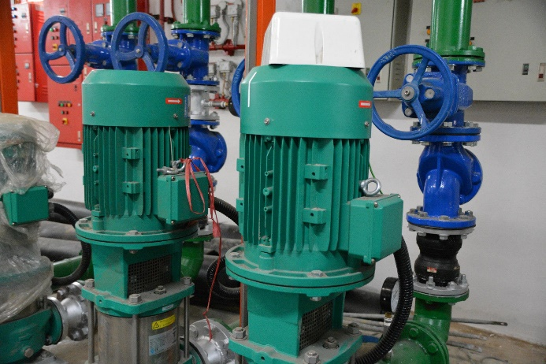
Figure 3: Centrifugal pump that act a kinetic pump that pump water from the R.C. Suction tank to dedicated water pipes to different area of the building.
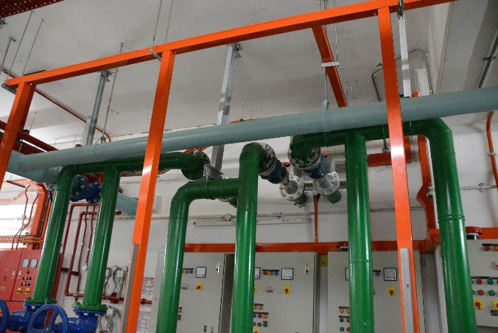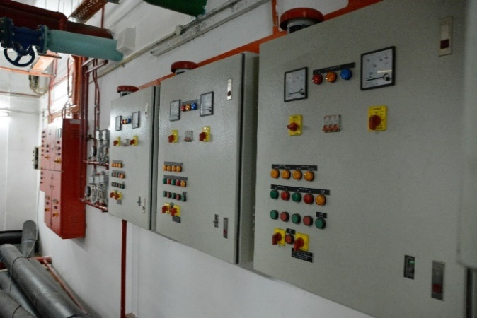
Figure 5: control panels that act to control the electrical pumps
Figure 4: Three pairs of water pipes carry water from the centrifugal pump to respective area of the mall
All the electrical pumps that uses to pump water from R.C. suction tank are control by the control panels. There are few control panels that control different area of the building.
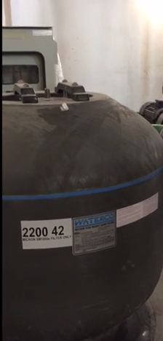
Figure 6: Sand filter on the roof area

Before water is pump to the domestic water tank on roof level (figure1). Water is needed to be filter, the filter tank used in Star Avenue are Sand Filter, which is quite costly where the M&E engineer told us.
With a Sand filter, water is filtered from top to bottom. Inside, a special filter sand (called silica sand), which has sharp edges that separate and trap particles, causes filtration to take place. Water is moved in two directions through this filter system. On the filtration cycle the water comes in through the top and filters down through the sand into the multi-lateral under-drain assembly. On the backwash cycle the water runs down and out this assembly forcing the contaminates and debris out of the sand enabling them to be flushed out of the system.
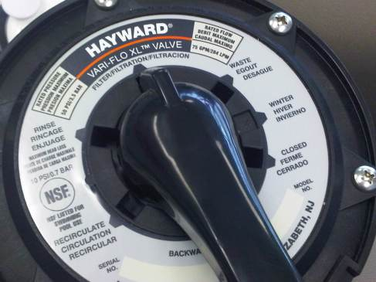
Figure 7: sand filter valve settings

The 6 Valve Settings of a typical Sand Filter:
- Filter / Filtration
- Backwash
- Drain / Waste
- Whirlpool / Circulation
- Rinse
- Winterizing/Close

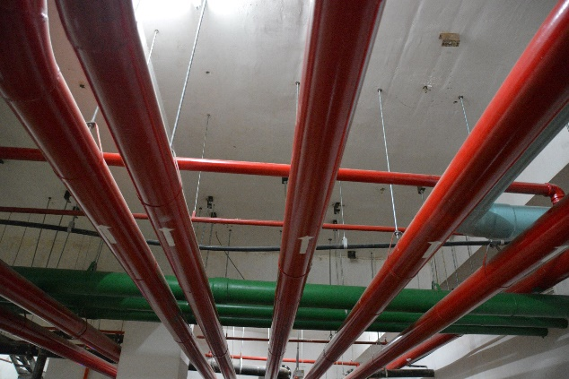
Figure 8: cold water piping (green)
Sprinkle water piping (red)
Pipe with green indication is the pipe which transport water to selected area from the water storage tank, whereas the R.C. sprinkler pipe is indicate in red.
Fire-Flow Requirement
UBBL
247
1) Water storage capacity and water flow rate for fire-fighting systems and installations shall be provided in accordance with the scale as set out in the tenth schedule to these By-Laws

The system must be capable of supplying the fire-flow specified plus any other demand that cannot be reduced during the fire period at the required residual pressure and for the required duration. The requirements of each system must be analyzed to determine whether the capacity of the system is fixed by the domestic requirements, by the fire demands, or by a combination of both. Where fire-flow demands are relatively high, or required for long duration, and population and/or industrial use is relatively low, the total required capacity will be determined by the prevailing fire demands. In some exceptional cases, this may warrant consideration of a special water system for fire purposes, separate, in part or in whole, from the domestic system. However, such separate systems will be appropriate only under exceptional circumstances and, in general, are to be avoided.
UBBL
247
(3) Storage tanks for automatic sprinkler installations where full capacity is provided without need for replenish shall be exempted from the restrictions in their location.

UBBL
247
(2) Main water storage tanks within the building. Other than for hose reel systems, shall be located at ground, first or second basement levels, with fire brigade pumping inlet connections accessible to fire appliances.

WATER SUPPLY
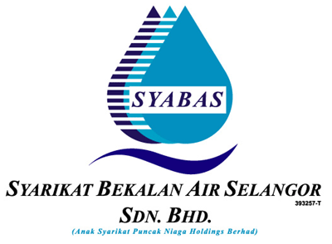
Source of water supply for Star Avenue comes directly from SYABAS, which generally stands for “Syarikat Berkalan Air Selangor Sdn. Bhd.” It is a company where it’s in charge of the water distribution in Selangor. Water Supply from SYABAS comes directly from the water main, underground and then being distributed to the water bulk meter which is located outside the parking area.

Pump System

Pump selection

The type of pump selected depends upon many factors. Including the yield of the rate of a well, the daily flow needed by user, the size of the storage tank or pressure tank used, and the total operating pressure tank is used , and the total operating pressure against which the pump works. First Cost, maintenance, and reliably are also factors, as is the energy used by the pump. In cold climates, a pump and water supply system must be protected from freezing.

Types of Pumps

Pumps commonly used for irrigation fall into the following categories based on the design of the pump. This tutorial addresses electric powered pumps only. While most of the information here also applies to fuel powered pumps the formulas don't! You must use different formulas for calculating the size and flow information for fuel powered pumps. If you have an engine powered pump (gas, diesel, propane, corn liquor, etc.) you should contact the pump manufacturer and request a copy of the pump performance curve. As a general rule, fuel powered pumps require more horsepower than electric pumps.

Displacement Pumps: Displacement pumps force the water to move by displacement. This means pumps such as piston pumps, diaphragm pumps, roller-tubes, and rotary pumps. The old fashioned hand-pumps, the ones you operate by moving a long lever handle up and down, are piston displacement pumps. So are those grasshopper-like oil well pumps. Displacement pumps are used for moving very thick liquids, creating very precise flow volumes, or creating very high pressures. In addition to oil wells they are also used for fertilizer injectors, spray pumps, air compressors, and hydraulic systems for machinery.

Centrifugal Pumps: Almost all irrigation pumps fall into this category. A centrifugal pump uses an "impeller" (sort of like a propeller, but a little different) to spin the water rapidly in a "casing", "chamber", or "housing" (any of those terms may be used). This spinning action moves the water through the pump by means of centrifugal force. Centrifugal pumps may be "multi-stage", which means they have more than one impeller and casing, and the water is passed from one impeller to another with an increase in pressure occurring each time. Each impeller/casing combination is referred to as a "stage". All centrifugal pumps must have a "wet inlet", that is, there must be water in both the intake (inlet) pipe and the casing when the pump is started. They can't suck water up into the intake pipe. They must be "primed" by adding water to the intake pipe and case before the first use. To prime them you simply fill the intake pipe with water and then quickly turn on the pump. To put it simply, this type of pump can't suck air, only water, so if there is no water already in the pump it won't pull any water up into it. Once it gets water in it the first time, most centrifugal pumps are designed to hold the water with a small valve so the pump doesn't need to be primed again every time you turn it on.

End-Suction Centrifugal Pumps: The most common type of pump. Typically the pump is "close-coupled "to an electric motor, that is, the pump is mounted right on the end of the motor's drive shaft and the pump case is bolted straight into the motor so that it looks like a single unit. The water typically enters the pump through a "suction inlet "centered on one side of the pump, and exits at the top. Almost all portable pumps are end-suction centrifugal type pumps. If the pump isn't one of the next two types, then chances are it is an end-suction centrifugal. End-suction centrifugal pumps generally need to be primed the first time they are used (including many so-called self-priming models,) after that most will not require priming unless a leak develops in the intake pipe. If the pump needs to be primed each time it is turned on this almost always means there is a tiny leak in the intake pipe.

Submersible Pumps: Submersible pumps are installed completely underwater, including the motor. The pump consists of an electric motor and pump combined in a single unit. Typically the pump will be shaped like a long cylinder so that it can fit down inside of a well casing. Although most submersible pumps are designed to be installed in a well, many can also be laid on their side on the bottom of a lake or stream. Another common installation method for lakes and rivers is to mount the submersible pump underwater to the side of a pier pile (post). Submersible pumps don't need to be primed since they are already under water. They also tend to be more efficient because they only push the water, they don't need to suck water into them. Most submersible pumps must be installed in a special sleeve if they are not installed in a well, and sometimes they need a sleeve even when installed in a well. The sleeve forces water coming into the pump to flow over the surface of the pump motor to keep the motor cool. Without the sleeve the pump will burn up. Because the power cord runs down to the pump through the water it is very important that it be protected from accidental damage.

Turbines and Jet Pumps: A turbine pump is basically a centrifugal pump mounted underwater and attached by a shaft to a motor mounted above the water. The shaft usually extends down the center of a large pipe. The water is pumped up this pipe and exits directly under the motor. Turbine pumps are very efficient and are used primarily for larger pump applications. Often they consist of multiple stages, each stage is essentially another pump stacked on top of the one below. It works like a train with multiple engines hitched together pulling it, each stage would be a engine. Turbine pumps are typically the type of pumps you see on farms. When you see a huge motor mounted on its end and a pipe coming out sideways below the motor, that is most likely the motor for a turbine pump down inside the well. I use turbine pumps for large parks and golf courses where we are pumping from lakes. The turbine pump is mounted in a large concrete vault with a pipe connecting it to the lake. The water flows by gravity into the vault where it enters the pump. The pump motors are suspended over the vault on a frame. I usually use two or three different sized pumps side-by-side to handle different flow combinations. A jet pump is similar to a turbine pump but it works by redirecting water back down to the intake to help lift the water.

Booster Pumps: Most pumps are used to take water from a standing (or non-pressurized) source and move it to another location. For example, a pump might take water from a lake and move it to a sprinkler system. A booster pump, on the other hand, is used to increase the water pressure of water that is already on its way somewhere. Example; say you have a sprinkler system that needs 80 PSI of pressure to operate. But the water line coming onto your property only has 50 PSI of pressure. In this cases you would install a booster pump to raise the pressure from 50 PSI up to 80 PSI for your sprinkler system. So to put it another way, a booster pump is used to "boost "the water pressure.

In Star Avenue
Hydro pneumatic system is used. The Hydro pneumatic system consists of a pressure vessels and a pressure pump. The pressure vessel contains water with a pressurized air space to provide the pressure for the system. With water demand, water flows from the vessels, increasing the air space as well as the as decreasing air pressure. The lower pressure signals the pump to start. The pump meets the demand with the excess volume backing up in the pressure vessels. This decreases the air space and increases the pressure once again. When the upper level is reached, the pump shuts off. The newer pressure vessels have a neoprene bladder to separate the air space form the water.
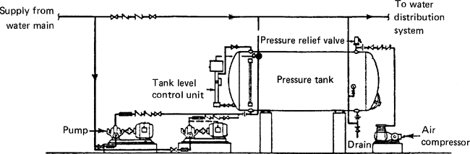
Diagram 1: Hydro pneumatic tank system

Water supply system in which water is pumped from the supply system into a pressure tank for storage. Air in the tank is compressed by the water entering the tank. As the pressure in the tank increases, the pressure in the water distribution system also increases, since its fed from the tank.

COLD WATER SYSTEM
The water supply comes from the R.C Suction tank located at the basement floor of the building and is pumped to the main domestic water tanks for storage, from the domestic water tanks, located on the roof level, the cold water is distributed throughout the basement via domestic water pumps. The building has 5 floors to distribute water to, and since the domestic pump is located above the floors, gravity is used to distribute the water to the lower floors.
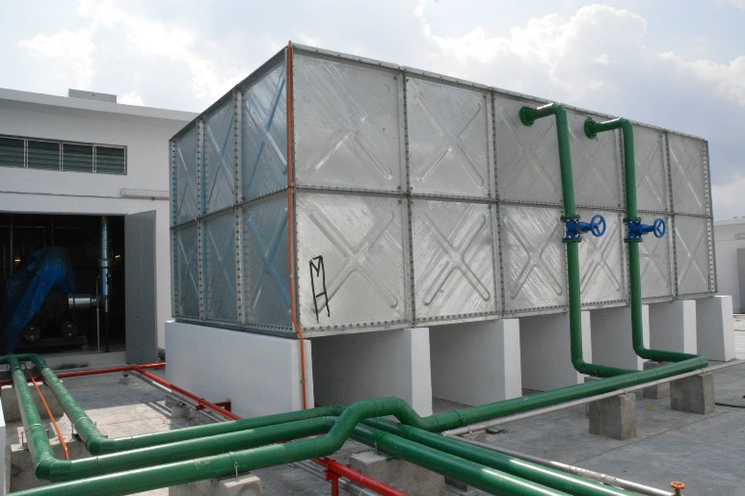
Figure 9: Domestic water tank

WATER PIPING
Water distribution piping varies according to their usage and functionality in supplying water to their designated areas. Each pipe sizes and material correspond to their respective distribution outlets in order to provide necessary pressure for the usage of the users.

MAINTENANCE
Maintenance is very important to prevent water supply failure. Usually due to leakage, data center will have the toilets to stand alone for almost all the floors. Maintenance in Security Commission Building is done once every month.
ANALYSIS
Cold water system used in Star Avenue is main water supply where they use water tanks to store in water from the suction tank to domestic tank and distributed evenly throughout the entire building. The benefits of using this system is that the water tanks reserves the water supply and is capable of providing water supply as preparation when shortage coming.
In this system, Water Pumps are needed to push up the pressure when the water supply from the main I low. In Star Avenue, the domestic water tanks are placed on the roof level that actually saving the cost instead of installing more pumps. Besides, the installation of water tank is a success which had fulfill the requirements set by UBBL By-Laws.

Conclusion
Based on our observation, this cold water distribution system is suitable for high rise building like in Star Avenue. As it has 5 floor to distribute the water. Three water storage tanks (figure 1) and 3 domestic water tanks (figure 9). Based on the study of water services in Star Avenue, This kinds of services are efficient and suitable, what we can recommend to this building is perhaps having some rain water collection tanks as I mentioned above from the sources of water. It will definitely help to reduce the usage of water from the water mains.

