Reflective Essay
I take a sip of coffee; I can feel it is going down my throat. Long queues of people are waiting at the corridor with their big luggage. Some were buying breakfast in the 7eleven. Some were yawning with their eyes popping while I am carrying my own bag at a dark corner looking for someone. Pink! Pink! Pink! Wait! I can hear someone is calling me! When I look back, I can see my friend is coming to me with their fancy clothes. All of them look fascinating except for me, one that still wearing sleeper and short pants. Everyone look so alert like they had been sleeping for years! 15 minutes later! The bus has arrived! “Someone shout.” All of us walk to the bus accordingly. After locating our luggage, we find our seats in the bus, of course with our own gang. As the sun light partially shine into the window.
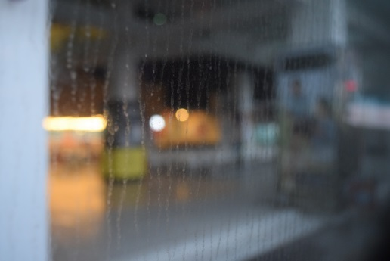
Everyone starts to wake up and talk. Most of them become talkative meanwhile the bus is filled with noises. As you can see some people are taking selfie while some is taking photo of the others.
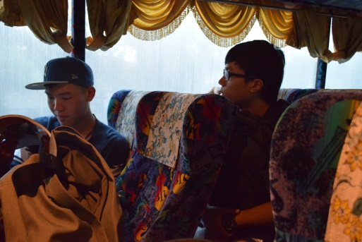
What an interesting sight, after 20 minutes. The bus starts to move like “I came in like a wrecking ball”! It just reminds me of a song. 2 hours later, stop after stop, pee after pee. We had our breakfast at McDonald. A trip that you won’t feel hungry.
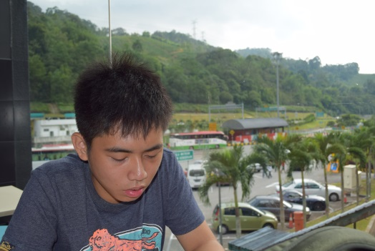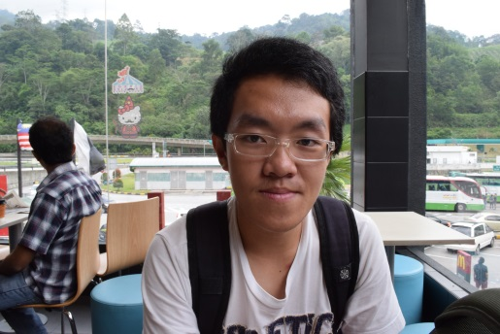

After meet up we back to the bus. And the journey continues. Until we arrive in Pahang right before Taman Negara. We had another lunch in a small restaurant. A traditional old building that looks like it has a lot of story behind it.
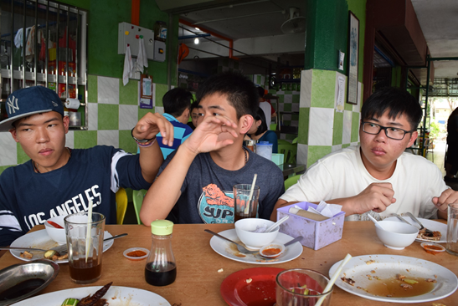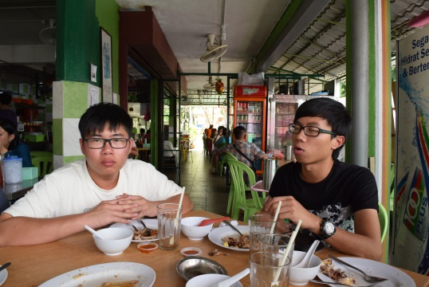
After the happy meal, we back to the bus and await to arrive in Taman Negara. Eventually, after a nap in the bus, suddenly I was awake by my friend telling me that we had arrived right in place. We collected all our luggage and walking to our hostel. The first impression of Taman Negara gives me a feeling of “a natural world without signals and technology”.
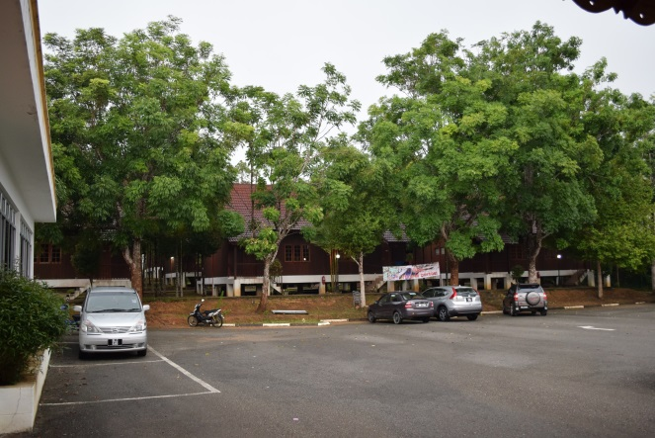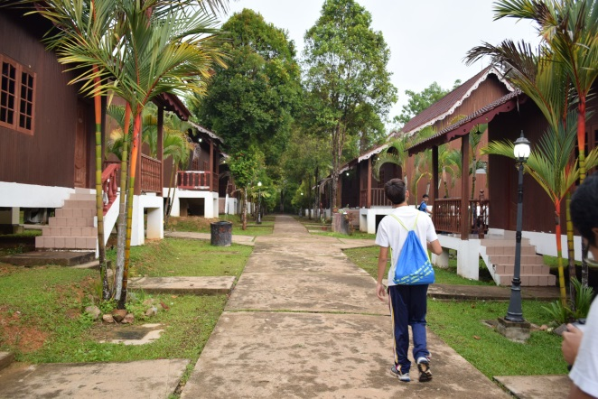
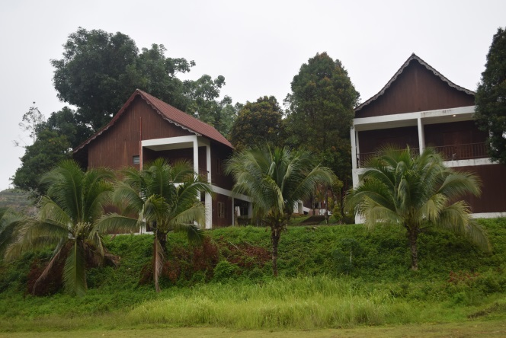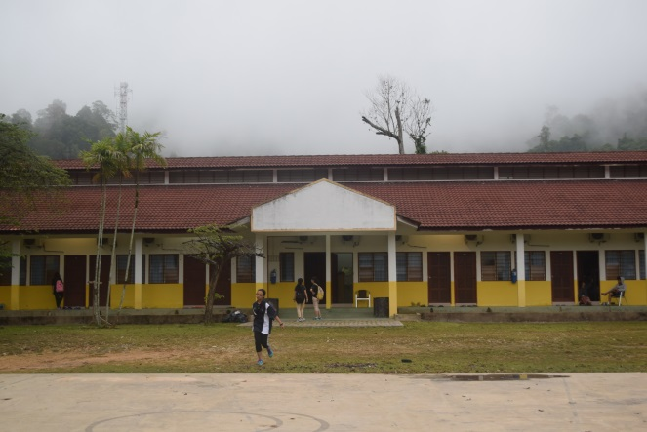
As the first night we stay in Taman Negara, I can feel the silent during the night, only the crickets’ and the birds are chirping. Being staying in the nature park, a different kind of experience that force us to live without technology. It is true that we came to this place to enjoy the nature. But I am kind of disappointed as the energy such as electricity are overusing in Taman Negara as you can see the houses are all installed with air conditional. I agree that the fact that we all can’t live without air conditional but perhaps we should endure and feel the natural air that flow in the nature park. I think Taman Negara should encourage people to enjoy the natural environment rather than adding air conditional or other technology that spoil the mood in the nature park.

Before the first activity in the first night, we had our dinner in a floating restaurant , a reuse boat that appear to be old like the ship in “pirates of the caribbean” but the restaurant look really impressive and it merge with the nature well as the ship is built with wood and doesn’t spoil the nature and its view.
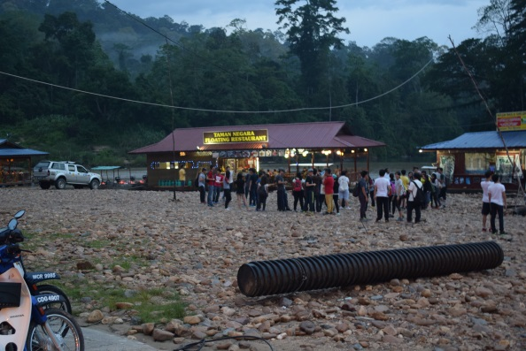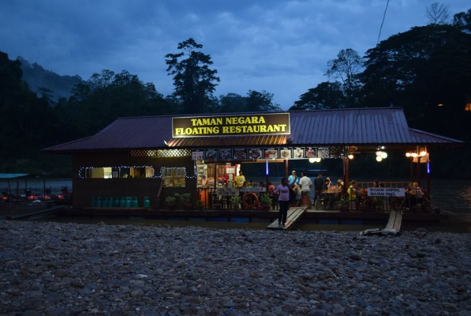
First activity that we had in the nature park is “jungle trekking”. Or I should call it “night safari”. The whole journey is without lights and well we all had to bring our own torch to indicate the way. There are some photos that I had taken in the jungle trekking that show how nature really looks like:
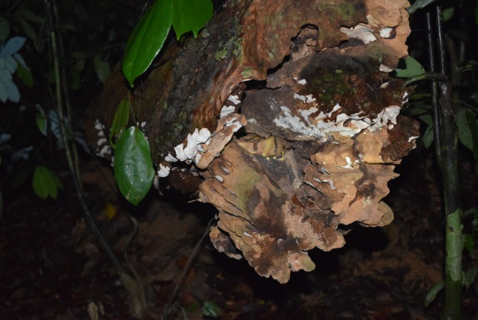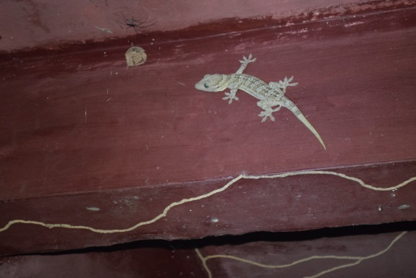
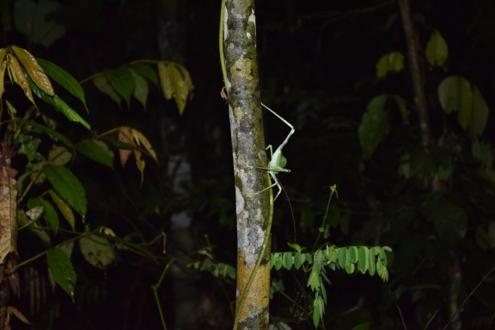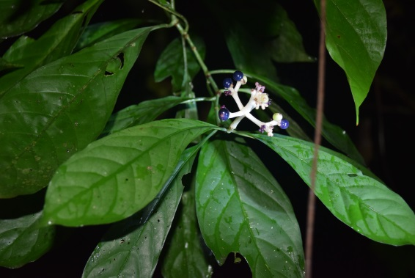
From my point of view, in jungle trekking many tourists had awakened the animals from rest. This is spoiling the ecosystem. It is like you are awaking someone from sleeping. I think the instructor/ guidance should limits the person that enter each time and make sure the tourists are not to make too much noise when they are in the trekking. Things such as torchlight had repelled the surrounding animal. They are all fear because of the noises and lights that we made.
In the second day, after we had our breakfast within the hostel. We begin with another activity which is the “morning walk” or “morning trekking”. From this trekking, I had learned how plants and their properties can bring advantages to human. Such as herbs and plant that can store water or use as soap. All this knowledge is important when we were missing in the forest. And all this will be our chance of survivor.
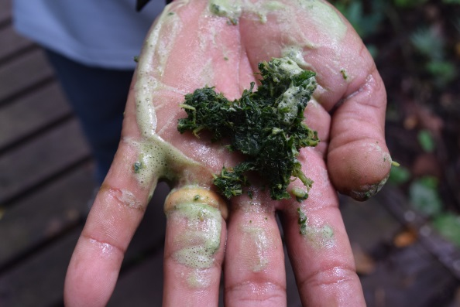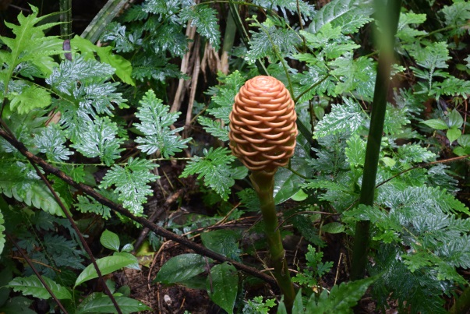
Before this, I saw some houses that built to merge with the site that looks interesting and most and doesn’t spoil the nature or the view. It looks extremely beautiful and I think all houses should be built like the one below.
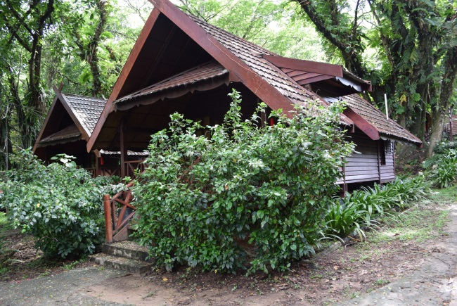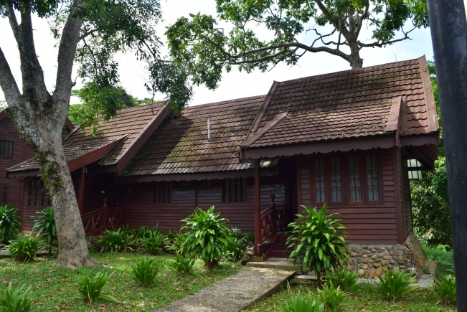
Houses from the same materials, materials that come originally from a tree had been used back to the nature. It is good that deforestation is not for unnecessary usage and I can see some good stuff in the nature park. Besides that I can see how Malaysian architecture style and elements appears in the nature park such as the ventilation holes and the Malayan style of windows is created. Time after time, after our lunch we begun with another activity which is a “speedboat racing”. Speedboat are fast and we enjoy the water fights among all of us. Being getting wet is not a good thing for me but the race was really fun. Meanwhile in the boat, i have seen how the mountain and trees are connected and I really enjoy the views. Perhaps we should have more time on enjoying the silent in the nature and not just noises from “water fight”.
After the water fight, it also lead us to the “Orang Asli’s house. With the instructor, they explained everything bout Orang Asli to us. We understood and had seen how the conditions of living they are actually having. They are a tiny community that had been abandoned by the government. Even though the government try to help them but it didn’t change their thoughts.
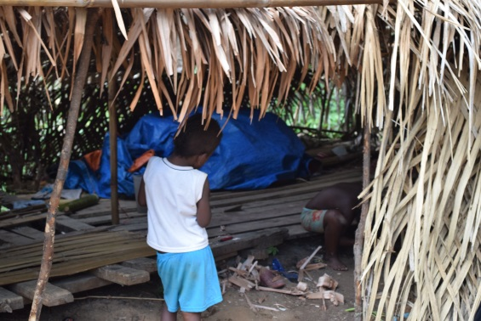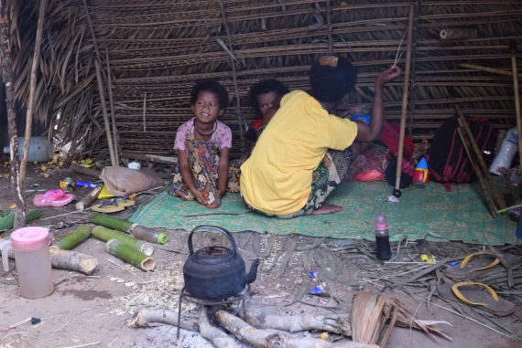
In my points of view, people may not see how Orang Asli reacts to our actions. As the tourist are trying to take photos from them, the adults Orang Asli was trying to avoid the camera. Despite that, people are still unaware and still taking photos of them. From here, I stand up and speak up for them. I really hope people will respect them even though they are the tiny abandoned community. Look carefully at how is their living and reuse materials from the forest to create shelter and helper to hunt for food. I really impress especially how they start the fire is like unexpected.
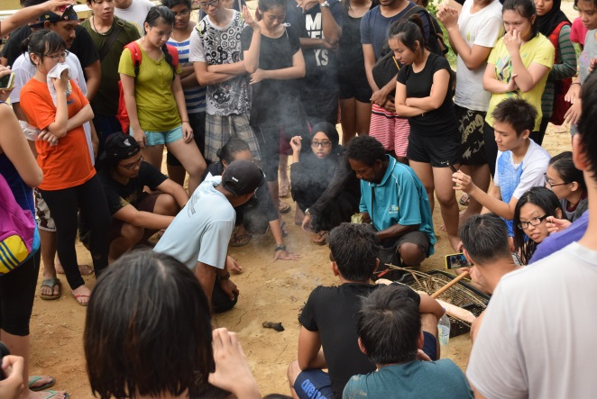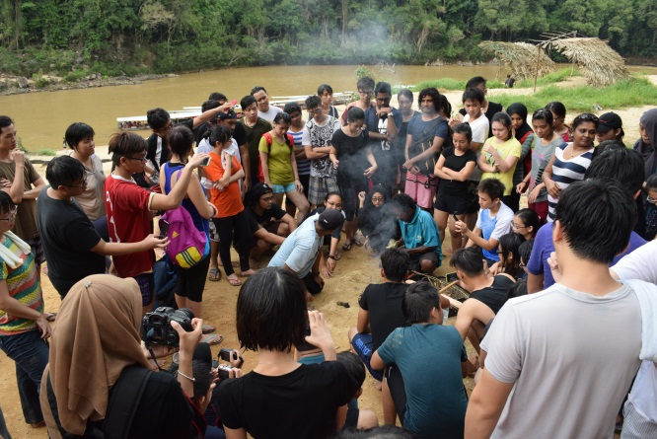
Day after day, time after time. It was the last day! We were all still in the nature mood and feeling like not spending time in the nature. But we still have to face the fact which is “assignments”! Yeah! After the pack up and last breakfast in the nature park, we all had a last group photo for this site visit.
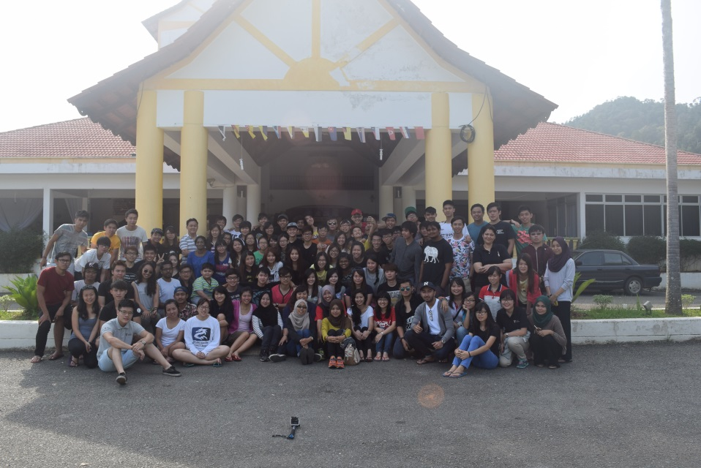
So yeah! That is the story of it. Thanks for reading!

